**Step 1 : List the running containers**

docker ps



**Step 2 : List all the containers**

docker ps -a

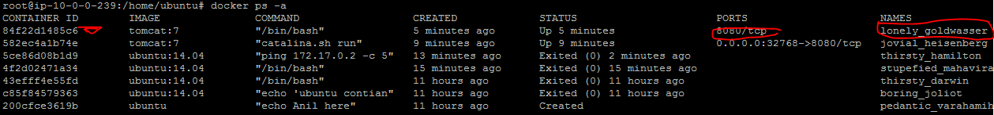

**Step 3 : Look at the CPU ,Memory and storage, network performance of container**

docker stats container1



**Step 4 : Restarting the container**

docker restart container1

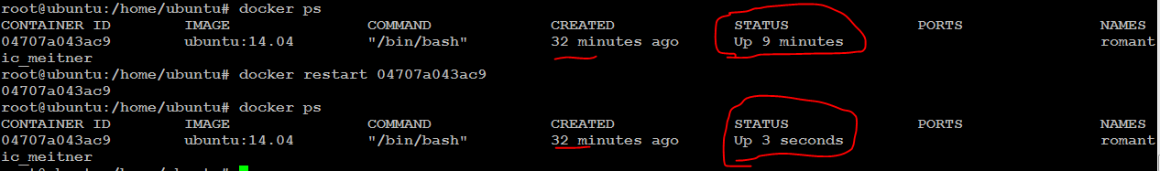

**Step 7 : Rename your container Name**

docker rename container1 web-server01



**Syntax : docker rename <continerid> <desired name>**

**Step 8 : Stop your container**

docker stop web-server01

**Step 9 : Start your container**

docker start web-server01

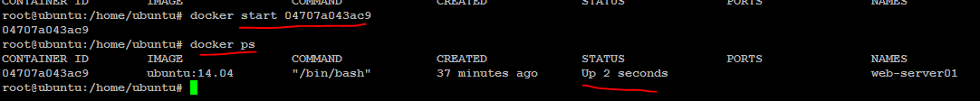

**Step 10 : Delete the container**

docker rm web-server01



Note : You cannot delete a container which is in start state

docker stop web-server01

**Step 11 : Delete the container**

docker rm web-server01

**Step 12 : Validate that the container is deleted successfully**

docker ps -a

**And also validate container doesn’t exist in /var/lib/docker/containers**



**Force delete of a container when container is running**

docker rm -f container2